URCaps Development, Testing,

and Deployment Using URSim

Version 1.0

9 September, 2025
Last edited by: Jeremy Marvel (jeremy.marvel@nist.gov)

Introduction
This guide provides instructions for configuring development environments, creating compiled URCap macros for the Universal Robots robotic platforms, and then deploying them to a physical robot, or a virtual robot using URSim. Some sections are specific to the Windows development environment, while others are platform agnostic.

This document does not provide instruction for writing URCaps. For such instructions, we recommend following the URCap Software Development Tutorial series for Java Swing and HTML. Both of these documents are included in the doc subfolder of the URCap SDK.

URCap Tutorial
Universal Robots also provides a convenient step-by-step tutorial for creating URCap macros, found at https://www.universal-robots.com/articles/ur/urplus-resources/urcap-my-first-urcap/.

It should be noted that following this tutorial did not produce a viable URCap for programming, as it did not include the Installation Node files. These can be created by making copies of the ___ProgramNodeContribution.java, ___ProgramNodeView.java, and ___ProgramNodeService.java files, and renaming them with “Installation” in lieu of “Program” in the file names.

The source files will also have to be updated to use “installation” instead of “program” in the function calls. The Activator.java file will also have to be updated to include calls to the installation files in addition to the program files. Refer to some of the sample programs provided in the URCap SDK for examples of how to achieve this.

API Reference
We also recommend leveraging the URCap API reference page, located at https://www.universal-robots.com/articles/ur/urplus-resources/urcap-api-reference-docs/, for information regarding specific method and function calls.

Installation and Configuration in Windows

Install the Development Environment
Enable the Windows Linux Subsystem (WSL) if not already enabled. Do this by clicking the Start menu button, and typing “Turn Windows features on or off” in the search field at the top of the menu.

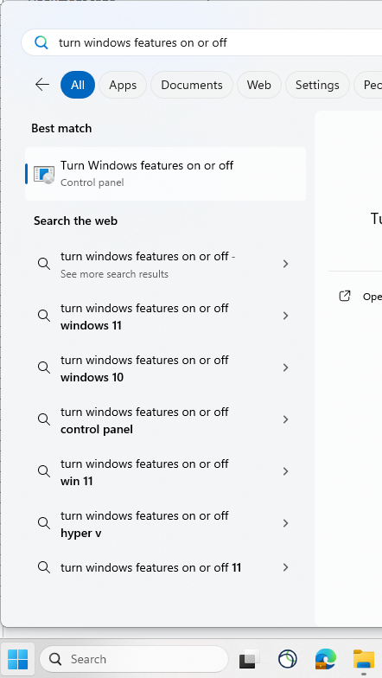
In the new window that opens, ensure the following are enabled:

→ Virtual Machine Platform
→ Windows Subsystem for Linux

Click “OK” and reboot the system.

Next, open the Microsoft Store, and search for “Ubuntu.” Select and install the latest version of the long-term support (LTS) Ubuntu environment.

Reboot the system.

Run the Ubuntu installation and complete the installation process. You will be asked to create a user name and password for the new installation. For simplicity, we selected “nist” as both.

Configure the WSL Development Environment
Once the Ubuntu installation is complete, it would be prudent to configure the development environment by installing necessary libraries and system shortcuts.

First, create a quick access link in Windows Explorer for easy access to the Ubuntu file system from Windows. In a new Windows Explorer window, access the path field, type \\wsl$\ to navigate to the local networked drive. Open the folder of the version of Ubuntu you are running, and then open the “home” folder.

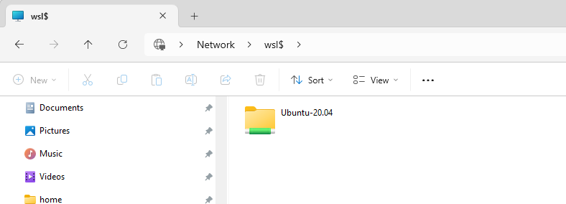

To create a quick access link, select the “...” from the menu (to the right of the “View” menu), and click “Pin to quick access.”

Installing the URCap SDK

Preparing the Development Environment for URCap Development
Open a new Ubuntu terminal window by pressing CTRL+ALT+T (or starting a new Ubuntu WSL terminal). Using this terminal, install the Java development kit and runtime environment, which will be used to compile the URCaps scripts:

sudo apt update
sudo apt install default-jre
sudo apt install openjdk-21-jre-headless

Next, install maven, which will be used to build and deploy the URCaps packages:

sudo apt update
sudo apt install maven
sudo apt-get install sshpass

Configure Ubuntu Environment for Bash
By default, the Ubuntu build uses Dash instead of Bash as its shell environment. Some of the scripts that come with the URCap SDK are incompatible with Dash, however, so Bash must be made to be the default shell environment.

To do this, run the Dash configuration tool from the terminal:

sudo dpkg-reconfigure dash

and select “No” to switch back to Bash.

Install the URCap SDK
Download the URCaps software development kit (SDK) from the Universal Robots website, located in the file downloads directory at:

https://www.universal-robots.com/download/software-e-series/support/urcaps-sdk/

Alternatively, you can find the URCaps SDK from the downloads directory, found at https://www.universal-robots.com/download/. Using the navigation bar on the left of the screen, select “Software,” and then checking the box next to “URCaps SDK.”

Once the file has been downloaded, extract the URCaps file into a separate folder, and then copy that folder to the home directory (see Section 2.2 if using WSL).

In the Ubuntu terminal, navigate to the directory you just copied over. The path should be something like: ~/sdk-<version>

Once in the directory, install the URCaps SDK by typing:

sudo ./install.sh

In some cases, you may encounter a “command not found” error. This is caused by the shell script command not being properly mapped in the WSL environments. It can be explicitly called by instead typing:

sudo sh install.sh

Installing URSim
It is recommended to leverage URSim for URCap testing, as it is significantly faster and less likely to cause damage to the robot than deploying unvalidated code to the physical robot controller. URSim operates as a virtual machine, provided by Universal Robots for this purpose. However, if you are deploying and testing directly on the robot, the instructions provided here are not necessary.

It is assumed that the URCaps SDK has already been installed correctly (see Section 3). Additionally, if you are developing and testing URCaps on a Windows computer, it is also assumed that the WSL environment has been correctly set up (see Section 2).

Install Virtual Machine Software
While any modern VM software should be compatible, this guide assumes the use of BroadCom’s VMWare Workstation Pro, and the specific instructions are presented based on this assumption. VMWare Workstation Pro is available for free for non-commercial use at:

https://www.vmware.com/products/desktop-hypervisor/workstation-and-fusion

Run the downloaded installation application, and follow the instructions for a full install.

  - Download the URSim Virtual Machine

While the VM software is being installed, download the URSim VM image from
https://www.universal-robots.com/download/. Using the navigation bar on the left of the screen, select “Software,” and then checking the box next to “Non-Linux Offline Simulator.”

Several versions of URSim available for download should be shown. Download the latest version (which should be at the top of the list of available versions). At the time this document was last updated, the latest version was 5.22.2.

Once the disk image has been downloaded, uncompress the file into a file directory that will allow you to easily find the image.

  - Setting up the URSim VM

Open the VMWare application, and select from the Home menu, “Open a Virtual Machine.”
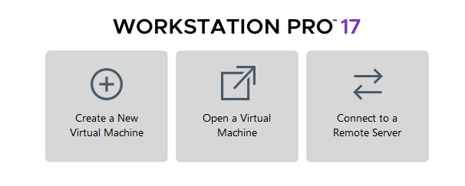
This will prompt you to select a virtual machine file. Navigate to the file folder where you moved the uncompressed disk image, and select the .vmx file there. At the time this document was last updated, the VM disk image name was “URSim_VIRTUAL-5.22.2.1214876.vmx.”

This will load the VM environment for the URSim lubuntu system, a linux distribution.

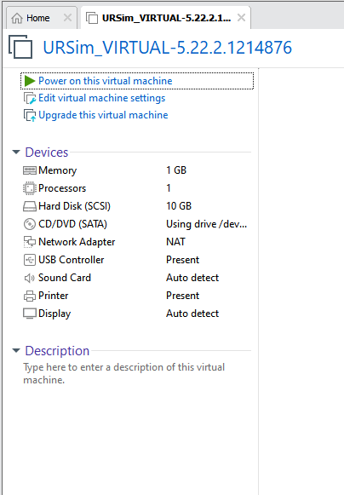

Start the virtual machine by clicking “Power on this virtual machine,” which will immediately start the emulation and load the Universal Robots Polyscope Simulator.

Open the virtual machine settings by selecting “Settings…” from the VM drop-down menu, or using the keyboard shortcut, ctrl-d. On the left of the pop-up window, select “Network Adapter,” and set the options to the following:
“Connected” is checked
“Connect at power on” is checked
“NAT: Used to share the host’s IP address” is selected

Click the “OK” button, and then restart the VM (ctrl-r)

The latest version of URSim does not provide the IP address of the virtual machine through the polyscope interface, so it must be manually recorded through the linux interface.

Once the lubuntu environment has reloaded, open the menu (lower left blue button), and open a new XTerm window by selecting “System Tools” → “XTerm.”

In the new window that opens, type:

ifconfig

Record the value of “inet addr” for eth0, as you will need this for deploying URCaps to the virtual robot controller.

Creating a Blank URCap Project
Universal Robots provides a shell script for automatically creating the file structure for a new URCap project. However, it should be noted that this shell script does not work on Dash, which is the default shell environment for Ubuntu. If you have not done so already, follow the instructions provided in Section 3.2 for configuring Ubuntu for Bash.

To run the script, create a new terminal window by pressing CTRL+ALT+T (or starting a new Ubuntu WSL terminal).

In the terminal window, navigate to the desired SDK folder. Once in the directory, install the URCaps SDK by typing:

sudo ./newURCap.sh

In some cases, you may encounter a “command not found” error. This is caused by the shell script command not being properly mapped in the WSL environments. It can be explicitly called by instead typing:

sudo sh newURCap.sh

You will be prompted to provide a GroupID and ArtifactID for the new URCap. The GroupID can be your initials or the name of your company, and is used to identify who developed the URCap. The ArtifactID is the name of the new URCap, and is typically indicative of the functionality of the URCap when installed.

Select “OK.”

On the next screen, you will be prompted to select which version of the URCap API you want to use. It is recommended that you use the latest version installed.

Select “OK” again.

The URCap is now ready for development.

Compiling and Deploying the URCap

Once you have completed the necessary edits to your URCap source code, you will need to use the maven compiler to create a deployable package.

Configuring the Target Paths
By default, the maven compiler can only create a local copy of the URCap package. However, it is capable of deploying directly to URSim or the physical robot controller.

To configure the compiler for direct deployment, create a new terminal window by pressing CTRL+ALT+T (or starting a new Ubuntu WSL terminal).

In the terminal window, navigate to the desired SDK folder. Once in the directory, run the maven project builder by typing:

sudo nano pom.xml

Navigate to the project installation properties entires, and update the host addresses for the URSim and physical robot:

<project>
<properties>
<urcap.install.host>IPADDRESS1</urcap.install.host>
<urcap.install.username>root</urcap.install.username>
<urcap.install.password>easybot</urcap.install.password>

<ursim.home></ursim.home>
<ursimvm.install.host>IPADDRESS</ursimvm.install.host>
<ursimvm.install.username>ur</ursimvm.install.username>
<ursimvm.install.password>easybot</ursimvm.install.password>

IPADDRESS1 is the IP address of the physical robot controller on your network, and IPADDRESS2 is the IP address of your URSim installation (previously recorded in Section 4.3).

Fill in the appropriate IP addresses, and be sure to update the username and password fields if these have been changed.

Save and close the document.

Creating the Compiled URCap Package
Create a new terminal window by pressing CTRL+ALT+T (or starting a new Ubuntu WSL terminal).

In the terminal window, navigate to the desired SDK folder. Once in the directory, run the maven project builder by typing:

sudo mvn install

Possible Error: Incorrect Versioning
Assuming there are no programmatic errors, the URCap project will build without issue. However, it has been observed that the default POM file created by the URCap generator does not always work due to an inappropriate versioning assumption. This is indicated by the following errors seen while compiling:
[ERROR] Source option 6 is no longer supported. Use 8 or later.
[ERROR] Target option 6 is no longer supported. Use 8 or later.

To fix this issue, open the pom.xml file for editing by typing

sudo nano pom.xml

Navigate to the maven compiler entry, and update the source and target values to be 1.8:

<build>
<plugins>
<plugin>
<groupId>org.apache.maven.plugins</groupId>
<artifactId>maven-compiler-plugin</artifactId>
<configuration>
<source>1.8</source>
<target>1.8</target>
</configuration>

Save and close the document, and try compiling again.

Possible Error: Erroneous State
On occasion the maven compiler will generate intermediate files that can create errors during compilation. If this happens, it can be helpful to force a recompilation of all intermediate files by typing:

sudo mvn clean install archetype:update-local-catalog

Deploying to URSim
Unless a destination target is specified during the compilation command, the maven compiler will create a local package that can be transferred to a robot for installation.

Alternatively, this package can be deployed directly to the URSim environment, assuming the compiler options have been set up correctly in Section 6.1.

To deploy to URSim, make sure the URSim VM is running, but no virtual robot is currently active.

On your development platform, create a new terminal window by pressing CTRL+ALT+T (or starting a new Ubuntu WSL terminal).

In the terminal window, navigate to the desired SDK folder. Once in the directory, run the maven project builder, and direct the deployment to URSim by typing:

sudo mvn install -P ursimvm

This will deploy the URCap to the URSim VM, and the new URCap will be available for use by all virtual robots. If a previously installed URCap exists, this process will overwrite and replace the older installation.

Deploying to the Physical Robot
The URCap package can alternatively be deployed directly to the robot controller, assuming the compiler options have been set up correctly in Section 6.1.

To deploy to the robot, make sure the robot is powered on, and the operating system is fully loaded and ready for user input.

On your development platform, create a new terminal window by pressing CTRL+ALT+T (or starting a new Ubuntu WSL terminal).

In the terminal window, navigate to the desired SDK folder. Once in the directory, run the maven project builder, and direct the deployment to the robot by typing:

sudo mvn install -P remote

This will deploy the URCap to the robot controller. If a previously installed URCap exists, this process will overwrite and replace the older installation.

Upon installation, the controller will automatically reboot, and the new URCap is available for use.

At the time this document was written, the most current version of the Ubuntu LTS is 24.04.1.
In some cases, the installation API calls are not equivalent to the program API calls, and individual inconsistencies will be pointed out while attempting to compile the URCap solution.

